1. In package.json add

ng build --configuration production

1. A screenshot of a computer

   Description automatically generated
2. 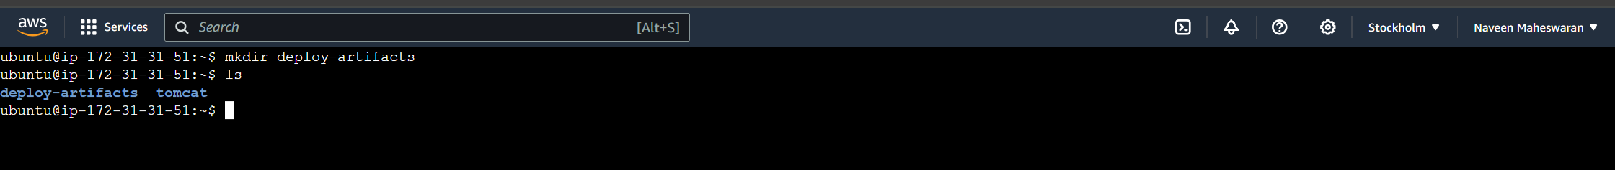
3. Transfer data to server via ssh client

1. Check files A screen shot of a computer

   Description automatically generated
2. Create a folder in tomcat webapps and copy files into it 